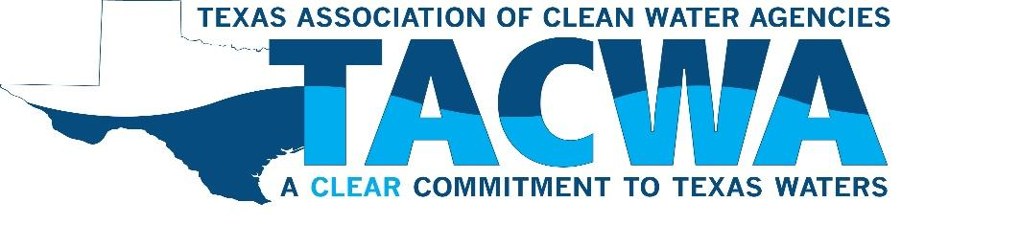

TACWA MEETING NOTICE

DATE: May 21, 2021

LOCATION: Virtual Meeting

HOST: Upper Trinity Regional Water District
SPONSORS: Arcadis, Brown and Caldwell, CDM Smith, Clean Water Strategies, CP&Y, Inc., Freese and Nichols, Inc., Garver, Gresham Smith, Gupta & Associates, Hazen and Sawyer, HDR, Inc., Isle Utilities, Lloyd Gosselink, Lockwood, Andrews & Newnam, Inc., Pacheco Koch, Parsons Water & Infrastructure, Perkins Engineering Consultants, Inc., Plummer Associates, Inc., Tetra Tech, Wastewater Training & Compliance, Weston Solutions Inc.

AGENDA

09:00 - 09:20 Welcome and Introduction/UTRWD Update – UTRWD Executive Director, Larry N. Patterson, P.E.

09:20 – 10:00 Business Portion and Regulatory Update

10:00 – 10:25 Presentation: Permitting Discharges to Lewisville Lake
Speakers: Brian Kelm with UTRWD; Chris Pasch, Ashley Lewis and Kristin Arnold with Plummer

10:25 – 10:50 Presentation: Updates on the 87th Texas Legislative Session: Law in the Time of Coronavirus Speaker: Julie Nahrgang, Executive Director, WEAT

10:50 – 11:15 Presentation: The Impact of PFAS on Municipal Utilities and Biosolids Management: A Cost Analysis
Speaker: Sarah Jakositz, E.I.T. with CDM Smith Inc.

11:15 - 11:30 Q&A/Open Discussion

11:30 Adjourn

